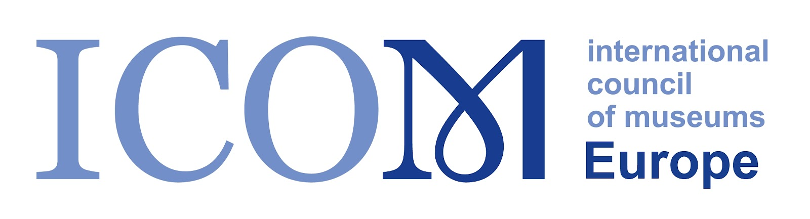

**ICOM Europe 2024 Conference “Heritage Resilience: Safeguarding Cultural Legacy in Crisis Zones”. Tbilisi, Georgia, November 28-29, 2024**

**CALL FOR PAPERS**

Join us in Tbilisi, Georgia, for the ICOM Europe 2024 International Conference, a landmark event dedicated to addressing the urgent challenges of protecting cultural heritage in crisis situations. This conference marks the 70th anniversary of the UNESCO Hague Convention for the Protection of Cultural Property in the Event of Armed Conflict, highlighting the critical importance of safeguarding our shared cultural legacy.

**Conference Dates**: November 28-29, 2024

**Location**: Tbilisi, Georgia

**Submission Deadline:** September 10, 2024

The ICOM Europe 2024 Conference will be preceded by a specialized training series from November 25-27, 2024, focusing on disaster risk management, emergency preparedness, and crisis communication. This training aims to enhance practical skills and strategies for safeguarding cultural heritage in conflict-prone areas.

Following the training, the conference will gather global experts to explore broader issues related to heritage protection under threat. We will examine best practices, roles of various entities, and strategies to prevent the intentional destruction of cultural assets. This event provides a platform for best practice exchange, addressing complex issues, and fostering international collaboration.

**Relevance and Context:**

This conference is particularly relevant given the significant challenges faced in heritage protection both globally and within Georgia. The conflicts, such as those in Abkhazia (Western Georgia) and South Ossetia (Samachablo), have resulted in substantial cultural losses, highlighting the urgent need for resilient heritage protection mechanisms. The ongoing conflict in Ukraine and other countries have further underscored the vulnerability of cultural heritage in crisis zones, drawing international attention to these pressing issues.

The deliberate destruction of cultural heritage remains a common tactic in warfare, aimed at erasing identities and disrupting communities. This conference seeks to address these critical issues by re-evaluating and redefining the roles of governmental and non-governmental entities in heritage protection, in alignment with international conventions. By examining recent instances of heritage destruction and other global occurrences, the conference aims to underscore the importance of implementing the principles of the 1954 Hague Convention.

**Conference Themes:**

* **Best Practices in Heritage Protection**: Ad hoc solutions, innovations, and case studies in safeguarding cultural heritage during crises.
* **Challenges and Complexities**: Navigating the multifaceted issues of heritage preservation in conflict zones, including legal constraints and safe storage solutions.
* **Role of Entities in Heritage Protection:** Exploring the collaboration between governmental and non-governmental organizations.
* **Role of Communications:** The dynamic roles of communications, community empowerment, and marketing during crises and in conflict zones.

**Conference Objectives:**

* Enhance global understanding of the complexities in protecting cultural heritage in crisis situations.
* Share best practices and innovative approaches to heritage protection.
* Foster international collaboration and strengthen networks among heritage professionals and organizations.
* Advocate for the implementation of the 1954 Hague Convention and other international frameworks for heritage protection.

**Submission Guidelines:**

* **Abstracts**: Submit an abstract of no more than 300 words.
* **Paper Length**: Full papers should be between 4,000 to 6,000 words.
* **Format**: Please follow the conference formatting guidelines, available on our website.
* **Submission**: Send your abstracts and full papers to [submission email address].

**Important Dates:**

* Abstract Submission Deadline: September 10, 2024
* Notification of Acceptance: September 30, 2024
* Full Paper Submission Deadline: November 15, 2024

**Organizers and Supporters:**

The conference is supported by ICOM and organized by ICOM Europe and ICOM Georgia, in collaboration with ICOM International Committees (ICOM DRMC, ICOM MPR), ICOM National Committees (ICOM France, ICOM Austria, ICOM Belgium, ICOM Italy), Blue Shield France, Blue Shield Georgia, Italian Opificio delle Pietre Dure, and Italian Istituto Centrale per Il Restauro.

We invite museum and heritage professionals, scholars, practitioners, and representatives from policy-making organizations to contribute to this significant conference. Join us in shaping the future of heritage resilience and safeguarding our cultural legacy.

For more information and to submit your papers,  contact us at [chair.icomeurope@gmail.com](mailto:chair.icomeurope@gmail.com); [lana.karaia@gmail.com](mailto:lana.karaia@gmail.com)